Category Taxanomy

Use cases:

1. **Create Categories.**

To create categories we first define all categories and subcategories under this header:

# Insert Categories

**INSERT_UPDATE** Category;code[**unique**=**true**];allowedPrincipals(uid)[**default**='customergroup'];**$catalogVersion**

Now we create the category-category relation(linking subcategories to the super category) to get the desired hierarchy under below header:

# Insert Category Structure

**INSERT_UPDATE** CategoryCategoryRelation;**$categories**;$supercategories

**Implementation Flow:**

1. In order to add categories and category-category relations we need to edit categories.impex under /sapbasketinitialdata/import/sampledata/productCatalogs/sapbasketProductCatalog



1. **Create Products.**

To create product we add products under this header:

# Insert Products

**INSERT_UPDATE** Product;code[**unique**=**true**];**$supercategories**;manufacturerName;manufacturerAID;unit(code);variantType(code);**$catalogVersion**;**$approved**

**Implementation Flow:**

1. In order to add products under various categories we need to edit products.impex under /sapbasketinitialdata/import/sampledata/productCatalogs/sapbasketProductCatalog



1. **Create enumtypes and itemtype for variant products.**

Create new product variant item type for sapbasket with two attributes code snippet given below:

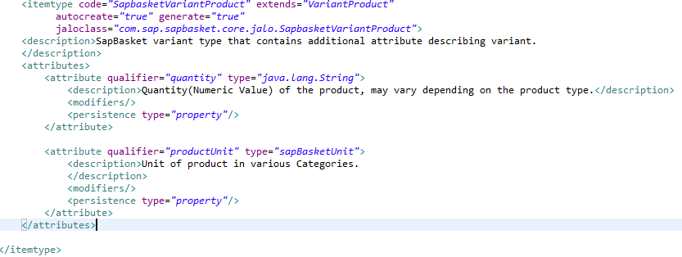

**Implementation Flow:**

1. In order to add product variants we edit variant_products.impex under /sapbasketcore/resources



1. **Create Product Variants.**

To create variants we add variants under this header:

# Create Variants

**INSERT_UPDATE** SapbasketVariantProduct;code[**unique**=**true**];**$baseProduct**;productUnit(code);quantity;supercategories(code,**$catalogVersion**);**$approved**;**$catalogVersion**

**Implementation Flow:**

1. In order to add product variants we edit variant_products.impex under /sapbasketinitialdata/import/sampledata/productCatalogs/sapbasketProductCatalog



1. **Add new currency.**

Implementation Flow:

1. In order to add new currency(INR) we edit essential-data.impex /sapbasketinitialdata/import/coredata/common

